BECOME AN AI AGENT & AUTOMATION ENGINEER
By Dr. Ryan Ahmed
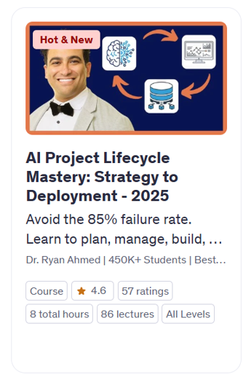
LIVE DEMO 1 – COPILOT AI ANALYST AGENT
Prompt 1
Context: You are an expert data analyst. You have the attached dataset and want to explore it visually to understand patterns and distributions.
Instruction: Create 10 different data visualizations to highlight various aspects of the dataset.
Input: cancer dataset (structured tabular data).
Output: A set of 10 clear and insightful data visualizations.

Prompt 2
Context: You are an expert machine learning engineer seeking to evaluate various machine learning algorithms to determine the most effective one for a classification task.
Instruction: Split the data into training and testing, and train five different machine learning models and compare their performance.
Input: Dataset.
Output: Table or chart comparing performance metrics (e.g., accuracy, F1-score, AUC) for all five models.

Prompt 3
Context: You have trained a machine learning model and want to understand which features contribute most to its predictions.
Instruction: Generate a feature importance ranking from the model.
Input: Trained machine learning model and the attached corresponding dataset.
Output: Ranked list or visualization of features by importance.

Prompt 4
Context: You have identified the best-performing machine learning model and want to assess its classification performance.
Instruction: Plot the confusion matrix and ROC curves for the selected model.
Input: Best-performing model and test dataset.
Output: Confusion matrix and ROC curve visualizations.

LIVE DEMO 2 – COPILOT & GEMINI AI RESEARCHER AGENT
Context:
You are a Ph.D. researcher specializing in next-generation electric vehicle (EV) technologies. Your organization is seeking a comprehensive, forward-looking briefing on state-of-the-art battery innovations that are expected to significantly impact EV performance, charging speed, safety, and sustainability over the 2025–2030 horizon.
Instruction:
Conduct an in-depth review and synthesis of emerging EV battery technologies projected to reach technical or commercial maturity between 2025 and 2030. Your focus should include, but is not limited to, the following areas:
- Solid-state batteries (including lithium metal and composite variants)
- Next-generation electrolytes supporting ultra-fast charging
- High-performance sodium-ion and sodium solid-state batteries
- Battery-swapping technologies and evolving recycling ecosystems
Include analysis of:
- Key performance metrics (energy density, cycle life, charging speed, safety improvements)
- Commercialization timelines and scalability
- Notable industry players and research institutions driving development
- Critical challenges and readiness levels (TRLs)
Input:
This is a standalone task. No external input will be provided.
Output:
Deliver a detailed briefing report that includes:
- Technology name and associated company/institution
- Breakthrough or innovation summary
- Quantitative performance indicators (e.g., Wh/kg, charge time, safety benchmarks)
- Implementation timeline and current stage of commercialization
The goal is to equip stakeholders with a clear understanding of transformative battery technologies shaping the EV landscape by 2030.

LIVE DEMO 4 – CHATGPT AGENT MODE

A. Booking Hotels
Find a 5-star hotel in Mexico City, on Booking.com for 2 adults from December 18th to December 28th. Try to keep the rate under $300 USD per night.

B. Managing Calendars
Create my calendar for next week (Monday Aug 4 to Aug 8) with an optimized, balanced schedule that prioritizes three things: health, family, and work. You decide the exact timing based on best practices for energy management and focus. Include:
- Daily time for physical activity
- Dedicated quality family time
- Focused blocks for deep work (teaching, research, content creation)
- Space for admin and meetings
- At least one evening of complete rest and one half-day off
Structure the day to maximize productivity while avoiding burnout. Make sure there are breaks, buffer time between tasks, and a sustainable pace. I will give you access to my calendar, allowing you to directly block time on it.

